CSCI 3320/8325, Program Assignment #2

Goal
The assignment has the following goals:
- Demonstrate your mastery of recursion
- Demonstrate your knowledge of how linked lists work
- Demonstrate your knowledge of stack and queue data structures.

Obtain the Starter Code
You can find the starter code in Python (see the attached file).
This code provides the complete code for a simple list that uses a singly linked list.
This code also provides some helper functions that you do not need to edit.

Part 1 (Expanding the linked list code)
Take time to familiarize yourself with the ‘printInOrder’ and ‘printNext’ functions. Your solution to this assignment will have code very similar to these functions.

Reverse the List (2 points)
Edit the code in ‘reverseList’ so that the elements in the list have been reversed.
You need to do this using recursion, not by using a loop or by copying the list.
You will probably want to add another function, for example one called ‘reverseRecursive’ to run the recursion properly. Again, look at ‘printInOrder’ and ‘printNext’ if you are stuck.

Convert the singly linked list into a doubly linked list (2 points)
For the given singly linked list implementation, convert it into a doubly linked list by adding the appropriate code to handle the ‘previous’ pointer.

Part 2 (implementing queue and stack):

Implement a queue using a Singly Linked List (3 points)
To implement a queue using a singly linked list, all the singly linked list operations should be performed based on Queue operations FIFO (First in first out). Do not add any changes to the implementation of a singly linked list. Use only the available methods.
You must implement the following stack operations:
- enqueue(): Insert a new element into the queue (i.e just insert a new element at the end of the linked list)
- dequeue(): Return the top element of the queue (i.e simply delete the first element from the linked list)
- front(): Return the front element of the queue
- printQueue(): Print all elements in the queue from the front element.
Note: The complexity of enqueue, dequeue and front operations should be O(c).

Implement twoStacks using a Doubly Linked List (4 points)
Create a data structure called twoStacks that implements two stacks by dividing a doubly linked list into two sections: one for stack1 and the other for stack2. Only the methods in the existing doubly linked list should be used for your twoStacks implementation. Do not add any methods to the doubly linked list.
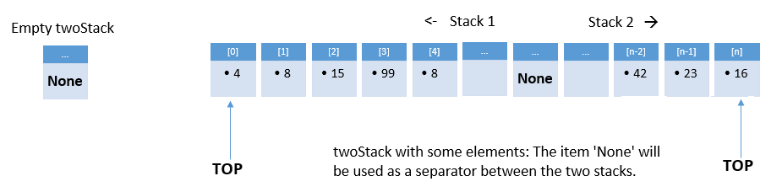
You must implement the following stack operations:
- push1(newItem):
  - Add a new item at the beginning of the doubly linked list.
- push2(newItem):
  - Add a new item at the end of the doubly linked list.
- pop1():
  - If stack1 is empty, print ‘Stack1 Underflow error’ and return.
  - Else pop the top item from stack1 (remove the top item).
- pop2():
  - If stack2 is empty, print ‘Stack2 Underflow error’ and return.
  - Else pop the top item from stack2 (remove the top item).
- top1():
  - If stack1 is empty, print ‘Stack1 is empty’ and return.
  - Else return the top item from stack1 (without removing the top item).
- top2():
  - If stack2 is empty, print ‘Stack2 is empty’ and return.
  - Else return the top item from stack2 (without removing the top item).

Note: The complexity of all operations listed above should be O(1).

Completion
Your program should have a menu driven user interface at the command line with the following options:
>> Enter choice [1-15] from menu below:
  - Construct a list L1 with a set of initial elements
  - Reverse the list
  - Print the list L1
  - Construct a queue Q1 with a set of initial elements
  - Print a front element of Q1
  - Dequeue from the front of Q1
  - Enqueue to the tail of Q1
  - Print the queue Q1 from the first to the last element.
  - Construct a twoStack T1 with a set of initial elements
  - Print a top element of S1
  - Pop from S1
  - Push to S1 (to the front of twoStack)
  - Print a top element of S2
  - Pop from S2
  - Push to S2 (to the end of twoStack)
  - Print the twoStack T1 (print the head to the tail of the doubly linked list)
  - Exit the program.

Note:
- ‘1) Construct a list L1 with a set of elements’ must take initial elements from the user.
For example, after the user selects option 1, your program should display the prompt: "Enter initial elements:". The user will then provide a set of numbers in a comma-separated format.
Enter initial elements: 12, 13, 11, 4, 7, 9, 3, 15, 8, 5, 6, 14, 2
- ’3) Print the list’ function can be called at any time while working with both Q1 and twoStacks to display the list items.
- ‘4) Construct a queue Q1 with a set of elements’ must take initial elements from the user.
For example, after the user selects option 4, your program should display the prompt: "Enter initial elements:". The user will then provide a set of numbers in a comma-separated format.
Enter initial elements: 12, 13, 11, 4, 7, 9, 3, 15, 8, 5, 6, 14, 2
- ‘8) Construct a twoStack T1 with a set of initial elements’ must take initial elements from the user.
When the user selects option 8, the program should prompt: "Enter initial elements for S1:". The user will input a series of numbers separated by commas. Similarly, the program will then ask for initial elements for S2 in the same format.
Enter initial elements for S1: 12, 13, 11, 4, 7
Enter initial elements for S2: 9, 3, 15, 8, 5, 6, 14, 2

Deliverable
A Python source codes (stack-queue-with-singly_linkedlist.py)
Justification of the complexity of twoStacks operations (in PDF or Word):
- push, pop, and top Stack operations for both Stack1 and Stack2

